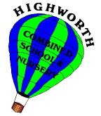

Supporting your child with phonics…

Reception and Key Stage 1

Set 1,2 & 3 Speed Sounds

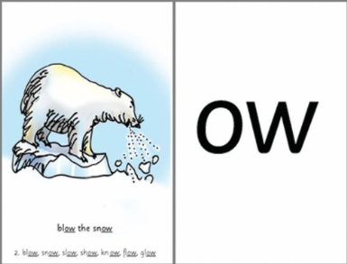
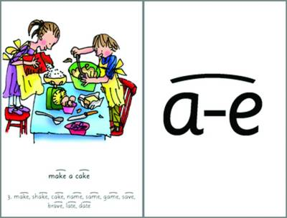

The information in this booklet will explain the phonics teaching that your child will receive daily at school during their time in Reception, Year 1 and 2.

It also provides information on how you can help support their phonic development at home.

If you need clarification or would like to know more about our phonics teaching, please make an appointment to speak to your child’s teacher or myself.

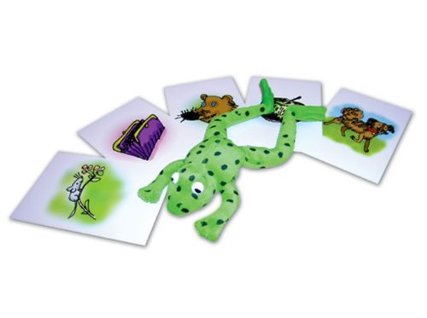

The information written in this pamphlet has been gathered from a variety of sources, including:
www.oxfordowl.co.uk
www.oup.com/oxed/primary/rwi/forparents/
In Reception, your child will start by learning the sounds below. They also learn how to blend them together to read words e.g. c-a-t cat.
Children will learn the sounds in the following order:

Speed Sounds Set 1
m, a, s, d, t, i, n, p, g, o, c, k, u, b, f, e, l, h, sh, r, j, v, y, w, th, z, ch, qu, x, ng, nk

What are speed sounds?
In Read Write Inc. phonics, the individual sounds are called ‘speed sounds’. This is because we want your child to read them effortlessly, ‘at speed’.
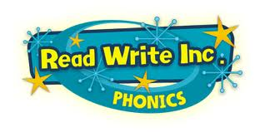

Speed Sounds Set 2
Once your child has mastered the set 1 speed sounds and is able to use these to sound and blend to read words they will progress onto learning their Set 2 sounds. There are 12 Set 2 ‘speed sounds’ that are made up of two or three letters which represent just one sound, e.g. ay as in play and igh as in high. It is important that your child does not pronounce these as 2 or 3 separate sounds. When they see the ‘speed sound’ letters together in a word, they must say just one sound for these letters, we call these sounds ‘special friends.’
When your child learns Set 2 sounds in school, they will learn:
- the letters that represent a speed sound e.g. ay
- a simple picture prompt linked to the ‘speed sound’
- a short phrase to say e.g. may I play

Set 2 Sounds ‘special friends’

ay: may I play
ee: what can you see
igh: fly high
ow: blow the snow
oo: poo at the zoo
oo: look at a book
ar: start the car
or: shut the door
air: that’s not fair
ir: whirl and twirl
ou: shout it out
oy: toy for a boy

Every speed sound has a list of green words linked to it, so your son/daughter can ‘sound out’ and ‘sound and blend’ words containing the new speed sound they have just learnt, for example s-p-r-ay spray.

Green words
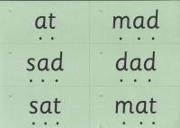
Every speed sound has a list of green words linked to it, so your child can ‘sound out’ and ‘sound and blend’ words containing the new speed sound they have just learnt, for example s-p-r-ay spray.. They look like this:

The dots under each letter is to remind children to sound each individual sound first, then blend them to say the word.

Red words
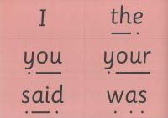
They can be thought of as the tricky words because you can’t ‘sound them out’ to read them. These words are common words that appear often in reading and need to be learnt by sight. We practise these words as part of our daily phonic session.

Speed Sounds Set 3
Once your child has mastered set 1 and 2 speed sounds they will learn the Set 3 sounds for reading (not spelling).
When learning the Set 3 speed sounds, your child will be taught that there are more ways in which the same sounds are written, e.g. ee as in tree and ea as in tea.

There are 20 Set 3 ‘speed sounds’ that are made up of two or three letters which represent just one sound, e.g. ea as in tea and are as in care. As before, it is important that your child does not pronounce these as 2 or 3 separate sounds.

When your child learns their Set 3 sounds in school they will learn:
- the letters that represent a speed sounds e.g. oa
- a simple picture prompt linked to the ‘speed sound’
- a short phrase to say e.g. goat in a boat
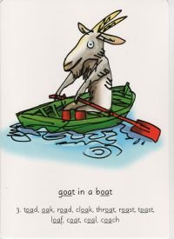

Set 3 Sounds
ea: cup of tea
oi: spoil the boy
a-e: make a cake
i-e: nice smile
o-e: phone home
u-e: huge brute
aw: yawn at dawn
are: share and care
ur: purse for a nurse
er: a better letter
ow: brown cow
ai: snail in the rain
oa: goat in a boat
ew: chew the stew
ire: fire fire!
ear: hear with your ear
ure: sure it’s pure?
tion: (celebration)
tious / cious: (scrumptious / delicious)
e: he me we she be
Children will apply their reading schools during RWI phonics lessons by using the RWI reading books.
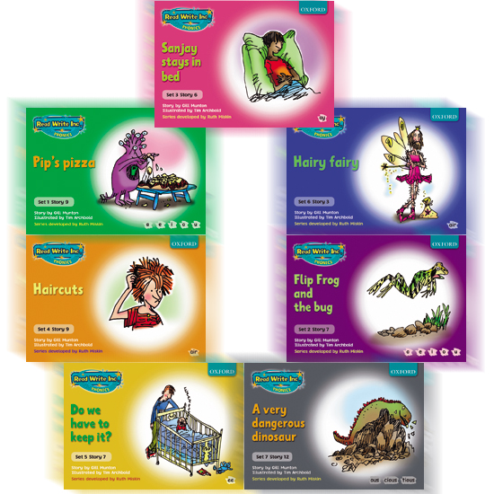

Activities to do at home together…

Reception

Learn and practise Set 1 ‘speed sounds’ from the Autumn term. Some children may master these during Reception and will move to Set 2 sounds when ready.

Year 1
Learn and practise Set 2 ‘speed sounds’ from the Autumn term move to set 3 sounds when ready.

Remember, when you practise the Speed Sounds, you either have to stretch or bounce it.

Resource for home use
Read Write Inc. Phonics: Home More Phonics Flashcards
These are great cards linked to the RWI phonics scheme.
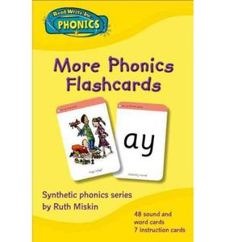

Internet
www.oxfordowl.co.uk/

Check your Phonics APP by Pearson Education

https://www.phonicsplay.co.uk/

Red Words

I | to | of | said
one | are | was | the
son | you | come | your
want | love | were | they
what | does | call | some
do | tall | all | many
any | talk | worse | once
small | bought | thought | through
caught | walk | buy | wear
two | great | should | would
there | here | where | who
watch | whole | anymore | water
brother | mother | father | other
above | school | could | no
many | are | mother | father
water | great | above | where
someone | walk | whole | anymore
water | brother | mother | father
other | above | school | could
go | me | her | old
we | be | so | he
by | my | how | over
now | saw | why | down
she

Green Words Set 1

1.1 | at | mat | sat | mad | dad | sad
1.2 | gap | pan | top | got | dog | pin
 | tip | pig | dig | sit | it | in
 | on | and | an
1.3 | up | cup | mud | kit | bed | get
 | met | bin | bad | cat | can | cot
1.4 | hen | hit | had | fan | fat | log
 | shop | fun | lip | fish | ship | let
1.5 | jet | wet | vet | yes | wish | web
 | yet | jam | yap | jog | win | yum
 | rat | red | run
1.6 | wing | chin | thick | chop | chat | quit
 | quiz | sing | thing | bang | this | thin
 | fix | six | zag | zip | fox | box
1.7 | stink | wink | back | skin | slid | slip
 | grin | prop | pram | from | clip | gran
 | hand | stand | stamp | flop | frog | jump
 | black | flag | think | skip | best | trip
 | blob | brat | drip | drop | blip | fluff
 | dress | huff | mess | test | trap | spit
 | stop | spot | strop

Green Words Set 2

2.1 | play | may | say | day | way | spray
2.2 | see | been | seen | three | green | sleep
2.3 | high | light | bright | night | fright | might
2.4 | blow | low | know | snow | show | slow
2.5 | too | food | moon | zoo | pool | spoon
2.6 | took | book | cook | look | shook | foot
2.7 | car | part | hard | start | star | sharp
2.8 | sort | short | horse | sport | fork | snort
2.9 | fair | hair | chair | stair | air | lair
2.10 | girl | bird | third | whirl | twirl | dirt
2.11 | out | shout | loud | mouth | round | found
2.12 | toy | boy | enjoy

Green Words Set 3

3.1 | clean | dream | seat | scream | please
3.2 | join | voice | coin
3.3 | make | cake | name | same | late | date
3.4 | smile | white | nice | like | time | hide
3.5 | home | hope | spoke | note | broke | phone
3.6 | rude | brute | June
3.7 | saw | law | dawn | crawl | paw | yawn
3.8 | share | dare | scare | square | bare | care
3.9 | burn | turn | spurt | nurse | purse | hurt
3.10 | never | better | weather | after | proper | corner
3.11 | how | down | brown | cow | town | now
3.12 | paid | train | paint | rain
3.13 | goat | boat | road | throat | toast | coat
3.14 | chew | new | blew | flew | drew | grew
3.15 | fire | hire | wire | bonfire | inspire | conspire
3.16 | hear | dear | fear | near | year | ear
3.17 | picture | mixture | creature | future | adventure | temperature
3.18 | delicious | suspicious | vicious | scrumptious | precious | ferocious
 | tradition | attention | celebration | conversation | congratulation | exploration

