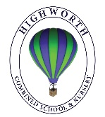
Year 1 Home Learning – Monday 27th April

Below, you will find 6 home learning tasks. You may choose the tasks that you wish to complete and do them in any order. Please do not hesitate to contact us if you have any queries or would like to share the work you have been doing.
year1@highworthcombined.co.uk
English  When we are learning about rhyming in class, we often sing the song, “I’m making lots of silly soup” to the tune of ‘Pop goes the Weasel.  I’m making lots of silly soup ,  I’m making soup that’s silly.  I’m going to cook it in the fridge ,  To make it nice and chilly.  In goes a ……..  Then we place an object in a bowl and stir it around. With each stir say another word that rhymes with the object in the bowl. For example, if I put a box into the bowl, the next stir we would say, fox, socks, blocks etc. with as many words that we can think of this. This is called a rhyming string.  - Play silly soup at home. Place an object from around your house in a bowl and stir with a spoon, sing the song and then with each stir think of as many rhyming words to go with that object.  - After you have played the game a few times write the list of rhyming words (the rhyming string) that went with your objects e.g. CAT- mat, bat, fat, sat, rat, hat.  - Now can you write a rhyming string list for words that rhyme with these words | Science  Today we are going to investigate floating and sinking. This is an activity involving water so you will need adult to support you to keep you safe.  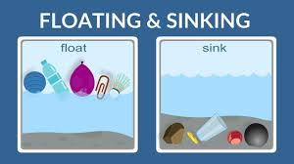  Collect a range of toys from around your house.  Make a chart like the one below with your toys in it and show your predictions of what you think will float and sink.  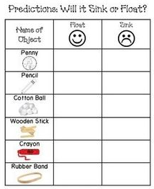  When you have made your predictions. Place each object into some water (a tray or your bath) and see if they float or sink.  Talk with your adult about what is happening each time you teat an object - is it the same as your prediction?  Record your results in another table to show what happened.  Now, write a sentence about what you found out and why you think that is.
  dog | hen | bug | pin
  bun | man | bed | sock
  soil | tear | shop | chip
  thin | ring | jog | vet
  rain | light | fork | cow
  mix | quick | three | band
  mouse | ball | frog | car
History
Today, your task is to make a fact sheet about Dinosaurs. The more facts and information you include, the more exciting it will be. https://www.twinkl.co.uk/resource/tp-l-52294-dinosaurs-ebook
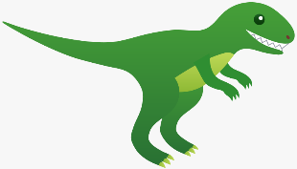
This link is to an eBook you can read to find out lots of information and facts about dinosaurs this will really help you make your fact sheet. You could draw and label a dinosaur and then include some facts you’ve found out about them – what do they like to eat, where do they live etc.

A little bit of information about Dinosaurs to help you
Dinosaurs lived many millions of years ago. Dinosaurs lived in every continent on Earth; more than 700 different species have been discovered worldwide we know this by looking at dinosaur fossils. While dinosaurs came a long time before humans, fossils and modern technology have helped us piece together what dinosaurs may have looked like and even how they might have behaved. Rather than being carnivores (meat eaters), the largest dinosaurs such as the Brachiosaurus and Apatosaurus were actually herbivores (plant eaters). A person who studies dinosaurs is known as a palaeontologist.
Music  Rhyming songs. In English today we were thinking about rhyming. We are going to continue this theme.  Lots of nursery rhymes have rhyming words in them:  - There was an old lady who swallowed a fly.  - Hickory dickory dock  - Hey diddle diddle  - Humpty dumpty  - I’m a little tea pot.  Write the lyrics for one of the above nursery rhymes, or another nursery rhyme you know that rhymes and underline the rhyming words in it.  Then, use the lyrics you have written out as a song sheet and perform the nursery rhyme to a family member.  Can they spot the rhyming words?  This link will take you to lots of nursery rhymes and lyrics if you are uncertain of any of the nursery rhyme lyrics.  https://www.bbc.co.uk/teach/school-radio/nursery-rhymes-hickory-dickory-dock/znpj47h  Challenge:  - Can you make props to help you perform he songs?  - Can you learn a new song that you didn’t know before?  - Can you make up your own song that rhymes? | Art and Design Technology  Do you know what a self-portrait is? (It is a an artwork of yourself.)  Look in a mirror at yourself. What do you notice? What colour are your eyes? What colour is your hair? What style have you got your hair in today? What are you wearing?  Place your paper this way up:  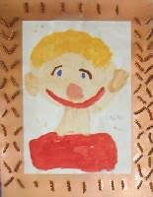  Now make a self- portrait, using any art materials that you have at home. Don’t forget to send us a picture of your art if you can!
Maths

Number bonds to 10 are pairs of numbers that add to make ten. In class we use ten frames to help us learn our number bonds. Draw your own ten frame like the one below.

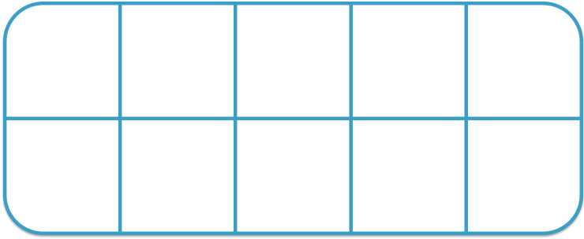

Find some objects that are two different colours ( counters, Lego bricks etc. would be perfect)
Place some in you ten frame. How many of the other colour will you need to fill your ten frame to make ten?
Repeat this several times and try and write down the number bonds to ten, using your ten frame and coloured objects to help you. Can you record your number bonds to ten like below?
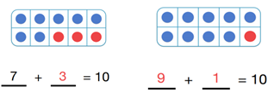

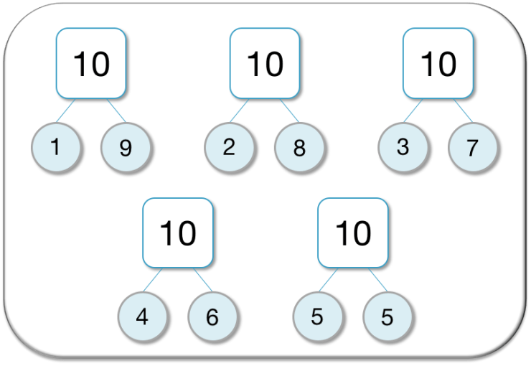
Challenge - Part, part whole models are good for practising number bonds to 10. Part, part whole models contain 3 circles with a larger circle connected to two smaller circles. The larger circle contains the number bond we are making, which in this case is 10. One of the smaller circles contains one part of the number bond and the other smaller circle is contains the other part that makes ten. We can show our number bonds in part whole models like below.
Draw your own part, part whole models to show the number bonds to ten without looking at the ones on this sheet.

