Year 4 Home Learning – Wednesday 24th June 2020
Please email us your work to:
Year4@highworthcombined.co.uk
Today, we are going to start 2 days with a dream theme!
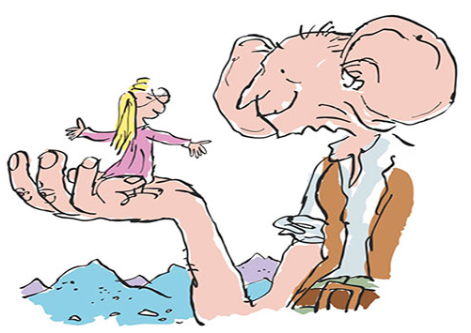
REMARKABLE WRITING!

Some of you may have read The BFG by Roald Dahl, but don’t worry if you
haven’t! There are 2 extracts from this book included as an attachment on
the school website for you to read. As you read them, think about this
question: What does Sophie find out that The BFG can do with dreams?

Here are 2 writing activities related to The BFG dream theme …

Attached below you will find a set of dream labels, each of which belongs to a dream jar from The BFG!  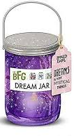  Choose 2 of the dream labels and imagine The BFG has tipped both of these dreams into one jar and he is whizzing them up with his gigantic egg beater.  What will happen? How will they  combine into one new dream?  Your task is to come up with a short  plot for this new, mixed dream.  How does the dream begin? What  happens next? How does the dream end?  We want you to make this as exciting as  possible. You might like to try the SPaG  activity to help you invent some new words (just like Roald Dahl did) to include in your writing. There is a writing frame to help you attached below.  Challenge: combine 3 dream labels into a single plot! |  | 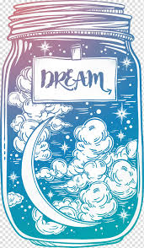  There are two different meanings of the word ‘dream’. There are the dreams we have at night, like the dreams The BFG blows through bedroom windows, but a dream can also be a personal goal which is something we really want to achieve. This could be something for the next few weeks and months or your long term dream for when you are older.  Have a think about your personal dream and then add it to the label on the dream jar below.  Then you can draw and colour what you think your dream will look like inside the jar – be as creative as you can to make your dream look extra special!
SUPER SCIENCE with a dreamy colourful theme!
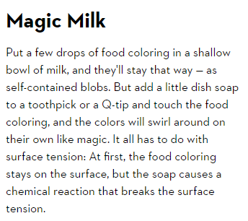
SKITTLES SCIENCE!
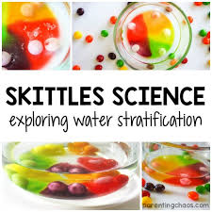
If you are able to get a bag of Skittles (or M&Ms),
you could try this fun science investigation.
The instructions are attached below. If you are
not able to get hold of Skittles right now, we are
sure you will enjoy watching this investigation
with this link:
https://www.youtube.com/watch?v=_bKRqELX6oI

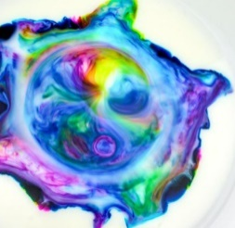
This clip shows you a wide variety of science fun!
You may find one you could try but watching these
will still fill you with wonder!
https://www.youtube.com/watch?v=McVpXiSttnU

MARVELLOUS MATHS!

Remember to keep practising your times tables and the associated division facts!
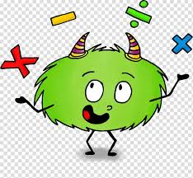
Mental maths skills are very important to support everything we do in maths, so we
have chosen an activity to help you practice your skills. They may be short
questions, but make sure you read them really carefully and think about the
vocabulary to make sure you give the right answer!

You can find the sheet on the website with the home learning matrices
as a pdf document.

WONDERFUL WELLBEING!    Time to take notice and spend some  peaceful time doing nothing except  lying on the grass watching at the  clouds.    Let yourself dream …  What shapes can you see?  Watch how they move …  How does it make you feel?  Please remember to find somewhere safe to lie on the grass. Please also remember YOU MUST NOT LOOK DIRECTLY AT THE SUN. | SPLENDID SPAG!  You can use this link to investigate the meaning of some of Roald Dahl’s wonderful vocabulary! There are many examples where he combined parts of two words to create a new one. For example:  Delumptious = delicious + scrumptious  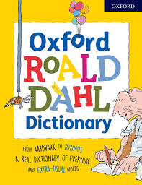  https://www.bbc.co.uk/newsround/36405434  There is a table with lots of Roald Dahl’s words  attached below and yes, there is a dictionary!  Can you work out how some of them were created?  Does that give you a clue as to their meaning?  Can you find some of these special words in the extracts from the BFG?  Can you work out what they mean either from how they were created or from what else is in the sentence around them (and what is happening in the text)?  Your challenge is to create some of your own new words to use in your writing for the activities above!
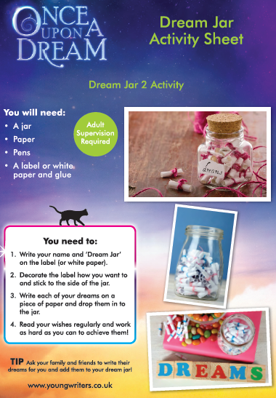
GET CREATIVE!

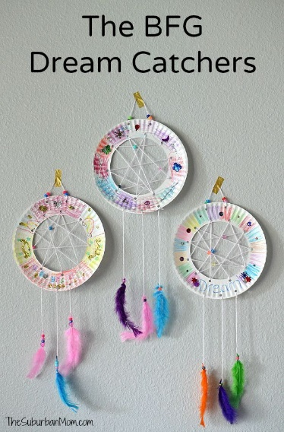
Here are two ideas for BFG
themed art and craft ideas.
Either of these could also be
completed as a design simply
on a piece of paper!

Rainforest wordsearch by Marium Ali
1
3
6
4
5
2

2. An underground part of a flower or plant. | 1. A little bit like soil, which helps flowers grow.
3. A piece attached to a stem of a plant. | 4. Lots of plants, trees and animals are found here.
5. A little bit like number 4 but it is under threat and is very wet. | 6. Where fruit and berries grow and where birds make nests.

Across Down

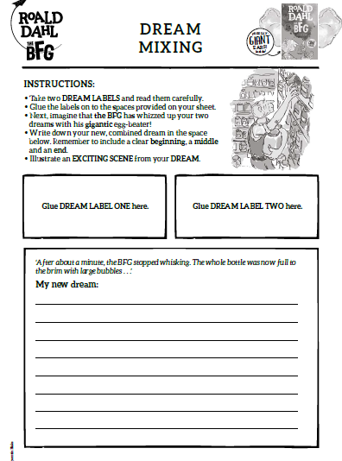
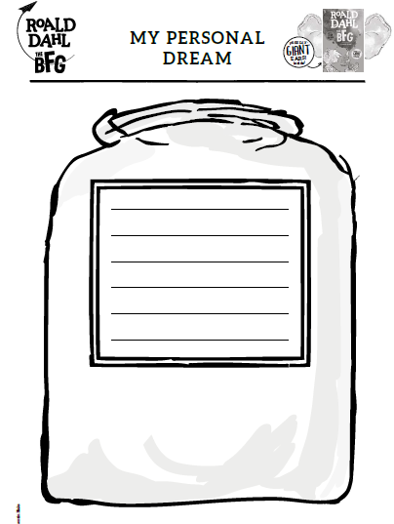
SKITTLES SCIENCE!
Remember, part of this Skittles experiment to create art was being creative and imaginative! Prepare to do it a few times, creating new art each time.
- Set out the supplies
You will need a good sized white plate, lots of Skittles (snacking will happen!), and water. Ensure you are set up in an area where the plate will not be disturbed. Any vibration or movement could affect your results.
- Arrange your Skittles
Consider what you want your art to look like and start arranging your Skittles in a pattern around the plate that you think will work best for your Skittles colorful art creation.
- Add the water
Gently pour the water onto the plate.
- Wait and watch
Very quickly you will start to see the colours travel. Watch to see how they move about the plate and what happens when they meet up with other colours. Depending on the size of your creation this will take about 10 minutes.
- Challenge!
Can you create a variety of different art pieces? You could try a happy face, a house in a meadow under a sunny sky, a starry night sky or a pattern of your own creation!

babblement  bellypoppers  Bloodbottler  bobstick  bogglebox  Bonecruncher  bootbogglers  buffsquiggled  bugswinkles  buphuggered  buzzburgers  buzzwangles  by goggles  catasterous  chatbag  chiddlers  crackling  crumpscuddle  crunking  dibbler  dogswaggler  exunkly  fibbler  fibbling  figglers  filthing  fizzwiggler | fluckgungled  flushbunking  flussed  foulpesters  foulsome  fridgy  frightsome  frobscottle  frogglehumping  gigglehouse  Gizzardgulper  glubbage  glummy  gobbit  gobblefunk  goosegruggled  grimesludge  grobswitcher  grubsludging  gunglummers  gunzleswiped  hipswitch  hotlands  humplecrimp  jabbeling  jipping  jumbly | kidsnatched  knack jife  Land of Noddy  maggotwise  maidmasher  Manhugger  Meatdripper  mucking  natterboxes  phizzwizard  pifflefizz  piggery-jokery  pigspiffle  pizzened  plexicated  pogswizzler  poisnowse  porteedo  prunty  quicksy  rack jobinson  ratrasper  razztwizzler  rotsome  rubbsquash  scotch hopper  scrotty | scrumplet  scrumsewer  septicous  shimozzle  skumping  slopgroggled  sloshfunking  slushbungle  snoozling  snortling  snozzcumber  squiddled  squizzly  strawbunkles  swackling  swallop  switchfiddling  swizzfigging  swogswalloped
