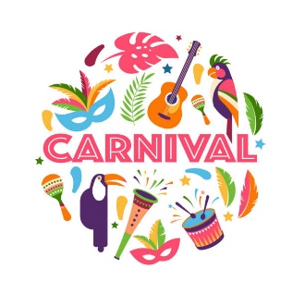
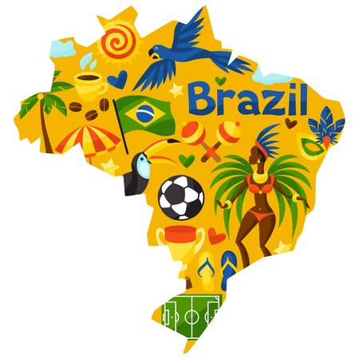
Year 4 Home Learning – Wednesday 10th June 2020
Please email us your work to:
Year4@highworthcombined.co.uk
Today, we’re off to Brazil for a couple of days of fun.
REMARKABLE WRITING!

Brazil is an amazing country full of a huge variety of history, geography, culture and so much more! For your writing activity we would like you to choose one of two tasks:

- CARNIVAL THEME POSTCARD

Brazil and its second largest city Rio de Janeiro are very famous for their carnival which is a
huge and very colourful event! You can use the pdf documents with the matrix on the
website, or find the same information on powerpoints on Twinkl to find out all about
carnival. As you look at the pictures and read the information, try to think about what it
would be like to be there! Use your senses to help you.

Now you are going to create and write a postcard to someone at home, imagining you have been at carnival. There is a postcard template (larger than a usual postcard size!) below. A postcard has a picture on one side and on the other side you write your message and opposite the message you write the name and address of the recipient (who you are sending it to!).

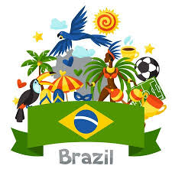
- FAMOUS PERSON OR BRAZIL (THE COUNTRY) FACT FILE
You can use the Brazil pdf documents on the school website as a starting point for your
research. You could create a fact file about the country of Brazil (climate, landmarks,
culture etc) or create a fact file about someone from Brazil who is famous (yes, that
includes many footballers!). Think about what you will include and how you will present
your information to make sure it draws the reader in and is informative.

GEOGRAPHY  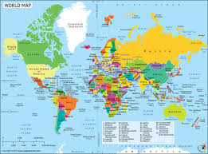  Time to practice some map skills! Using the information in the Brazil document, or from your own research, can you complete the map activity attached below?    Challenge: Look at the information about the cities in Brazil that tell you about human and physical features.  Can you explain the difference between these features?  Can you think of some human and physical features in our area, in England, the UK or another country? | GET CREATIVE!  You will now know that carnival time in Rio is bright, colourful and full of all things creative!  We would like you to be inspired to be creative with a carnival theme. You could:  - Make a colourful poster about carnival.  - Make you own carnival mask    - Create a carnival themed mindfulness colouring sheet.  Carnival is also filled with music and dancing. Samba music and dance are seen a lot at carnival. You can use these links to learn about samba music and the second one has 2 short videos with some samba moves! Enjoy!  https://www.twinkl.co.uk/resource/t2-mu-129-samba-activity-pack  https://primaryschooldance.co.uk/2016/05/10/football-world-cup-samba-dance/
MARVELLOUS MATHS!

Times Tables and division practice for quick recall. You can use this link: https://www.topmarks.co.uk/maths-games/daily10 Don’t forget you can use Daily 10 to practice other mental maths skills too! Let us know about any you have tried and how you got on. Remember that you can practice these skills without the internet, using the ideas in previous matrices.

Money, money, money!
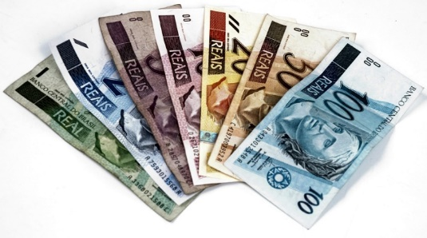

1 pound is equal to 6.74 reals.
Rounded to the nearest real, how much would 1 pound be equal to?

You are correct, 1 pound is approximately equal to 7 reals. Whilst preparing for a trip to Brazil your travel agent gave you a carnival price list in pounds. As you want to attend the Carnival and realise that there is so much to spend your money on, you decide to work out how much you will need. This will mean that you can be sure to take enough money with you.

- You buy a ticket, a mask, a musical instrument, a main meal and a dessert. How many reals will you need?
- What is the minimum amount you could spend if you buy the items listed above?
- CHALLENGE: Your family decides to go with you. You each buy a ticket, a mask, a musical instrument, a main meal and a dessert. How many reals will you now need to take with you?

WONDERFUL WELLBEING!    You have already done some keep learning with all you have learnt about Brazil and carnival. You may have also included some be active with some samba dancing!  Can you write down 5 interesting or fun facts you have learnt and then connect by sharing them with someone else? Can you think about a fun and different way to share them?  Thank you to Amber for creating and sharing this wonderful wordsearch . Why not have a go and see if you can find all these common exception words.  The wordsearch can be found at the end of this document. | SPLENDID SPAG!  Words that you just have to know how to spell!  List the following words and check that you have copied each word correctly. Make sure you use neat joined handwriting.  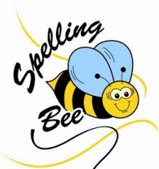  disappear  early  earth  eight  eighth  enough  Find a fun way to practice!  Next ask someone to test you!  Now write some silly sentences using at least two words in each sentence.  Challenge: create a wordsearch of common exception words. Remember to include a list of the words that are included. Send it to us and we may include it with a future matrix!

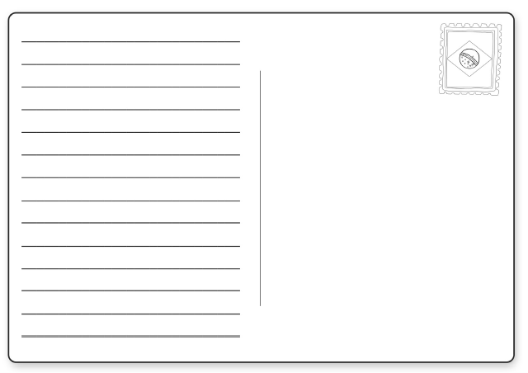


Pricelist

Ticket Prices

Adults: £ 52
Children under 13 : £26


Masks
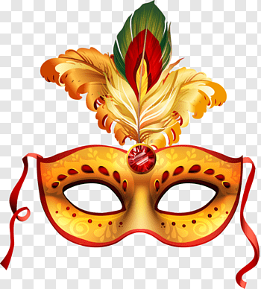
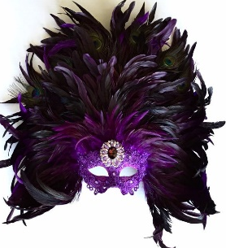
£8
£27
£15
£50


Instruments
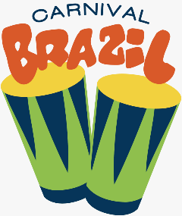
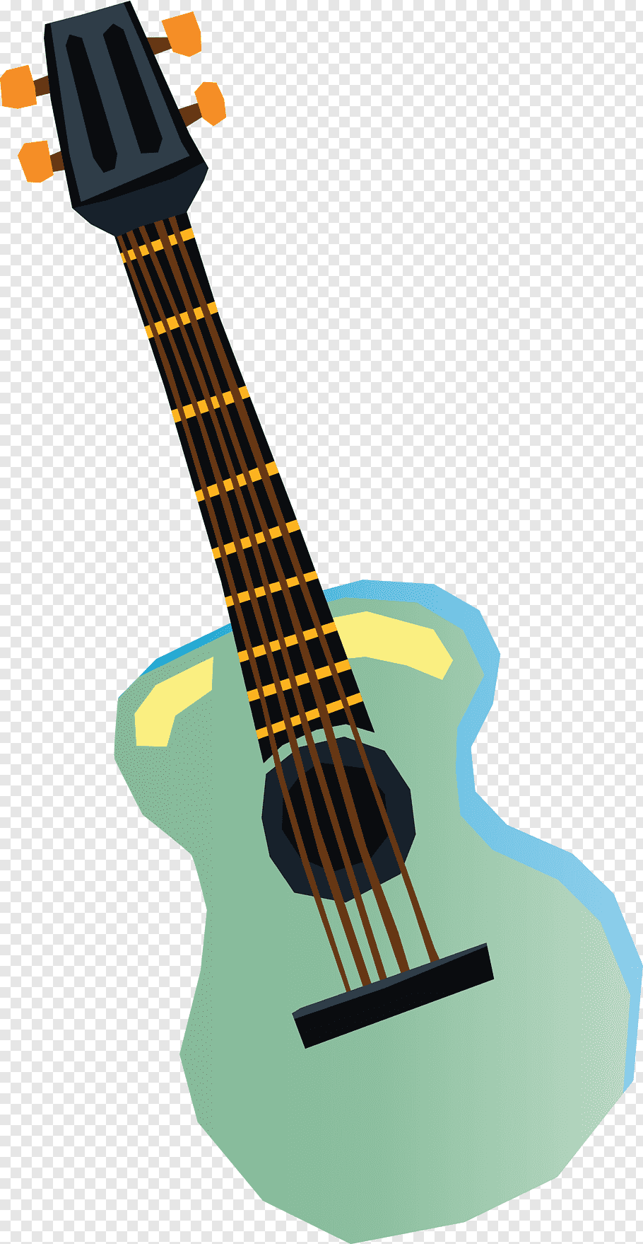

£30
£5
£9
STREET FOOD
MAIN MEALS
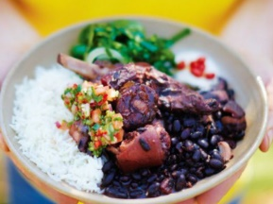
£22
feijoada (slow-cooked pork and beans with rice)

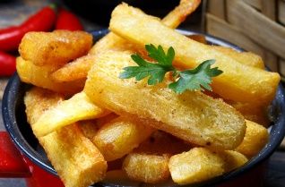

Aipim Frito (chips made from cassava)
£10 101110101

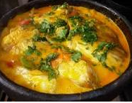

£25
moqueca baiana (a fragrant fish stew)

DESSERTS
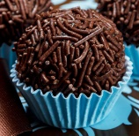
£4

Brigadeiro

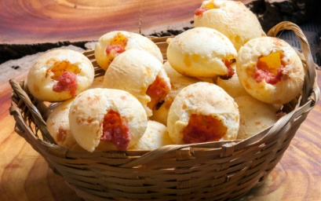
£6

Pão de Queijo
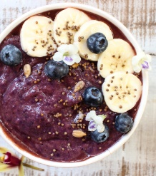
£13

Açai Na Tigela

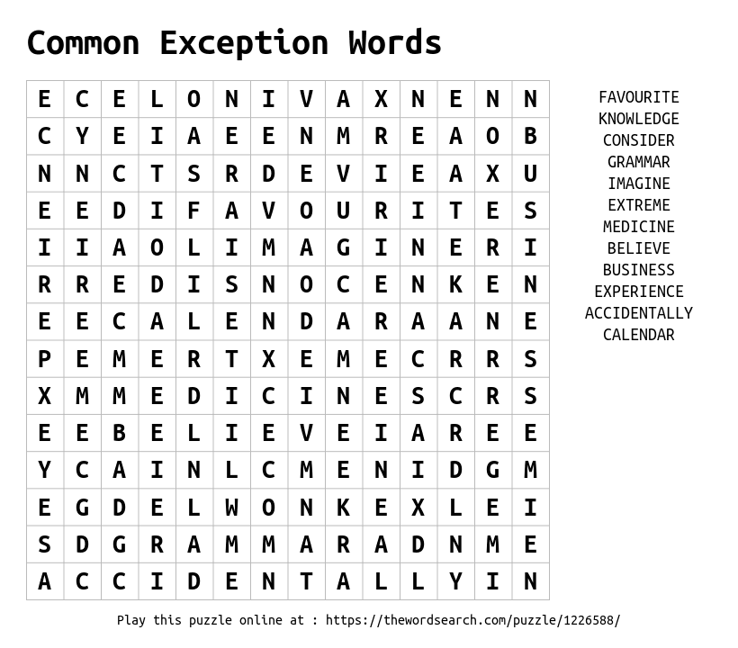

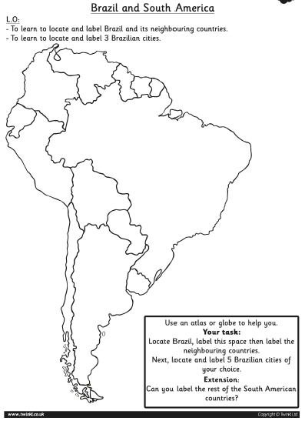
YOUR TASK:
First, locate Brazil, label it and colour it in one colour.
Then locate, label and colour the neighbouring countries.
Next, locate and label 5 Brazilian cities of your choice.
Challenge: Can you label the rest of the South American countries?

