Year 2 Home Learning
Week Commencing 15 June 2020- Monday
Please send your work to- year2@highworthcombined.co.uk
We always look forward to seeing your work. Please let us know if you need any help or have any questions.
English Task  Today you are going to write a paragraph encouraging someone to watch a show you recommend or to play a game that you really like. What would they like about the show? Why is it good?  Here is my example-  The show is about nature. The show has lots of animals. The show is good.  Now I have written a bit, but I think you will agree it isn’t very good. What do we need to make this more interesting?  -adjectives- describing words  -Sentence openers- think of different ways to start each sentence  -Examples of what was good/ details  Let me try that again.  Last night I watched an amazing program called ‘Our Planet’. David Attenborough travelled around the world in an epic program where you get to see animals in a way you never have before. I watched an episode about different sea birds. One minute they were soaring in the air and the next they were swooping down in to the water. It was brilliant!  Have a go writing your own paragraph. Don’t forget to make it interesting! | Maths  Warm up-  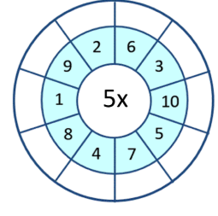  Division-  Many of you are starting to become more confident with arithmetic. Now we need to develop your reasoning and understanding.  Carefully read the questions below and draw pictures to explain your answers.  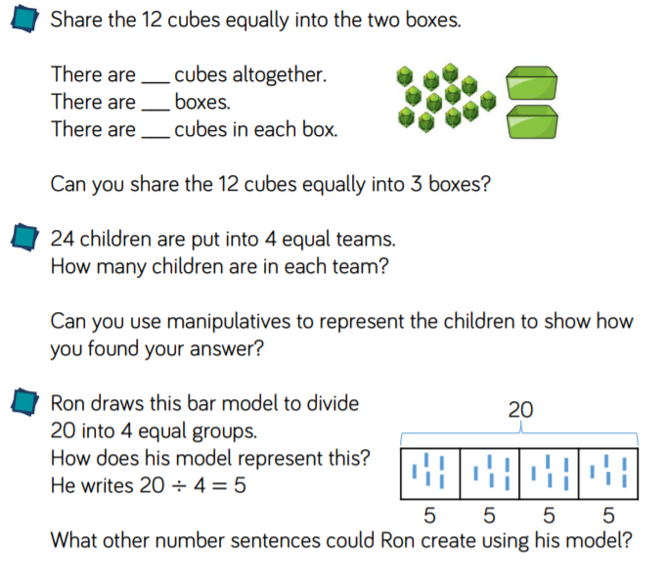  Challenge- Write your own division word problem using a bar model.
Geography  We have looked the 7 continents. Can you remember all of them?  Asia, Africa, North America, South America, Antaritica, Europe and Australia.  Asia is separated from the continent of Europe by a land border and edged by three oceans: the Indian Ocean to the south, the Pacific Ocean to the east and the Arctic Ocean to the north.  Follow the link and learn more about the continent of Asia and the country China.  https://www.bbc.co.uk/bitesize/articles/zfcbrj6    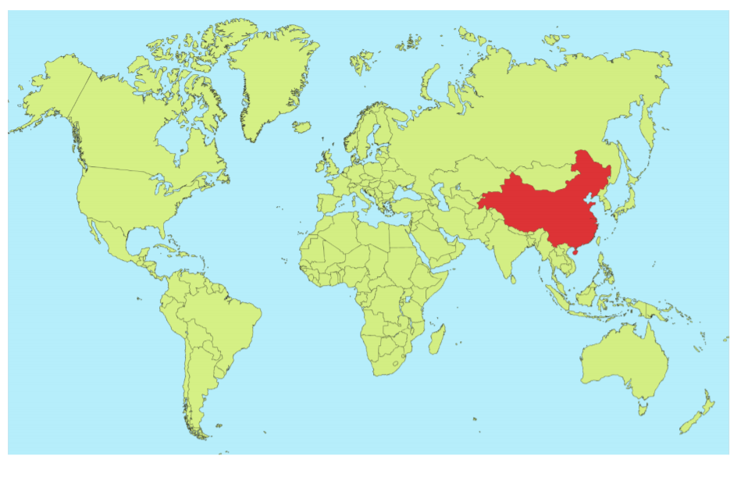  Complete the map activity at the end of the lesson.  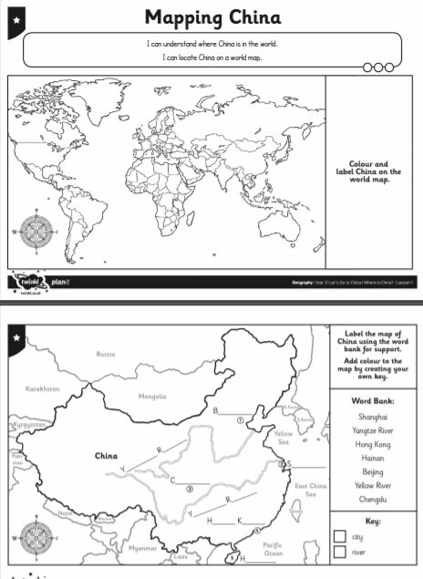 | Spelling Task  This week we are looking at different words that end with the ‘l’ sound spelt ‘le’. I have included a picture of our sound chart. Can you think of a word that uses each of the sounds?  .  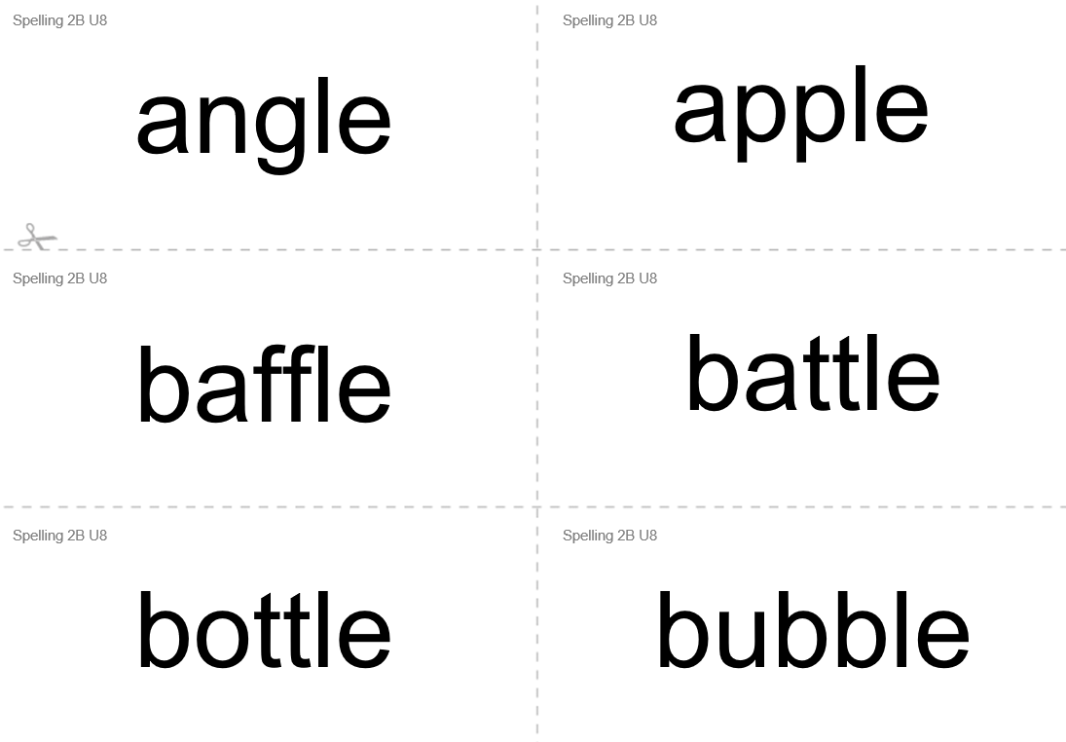  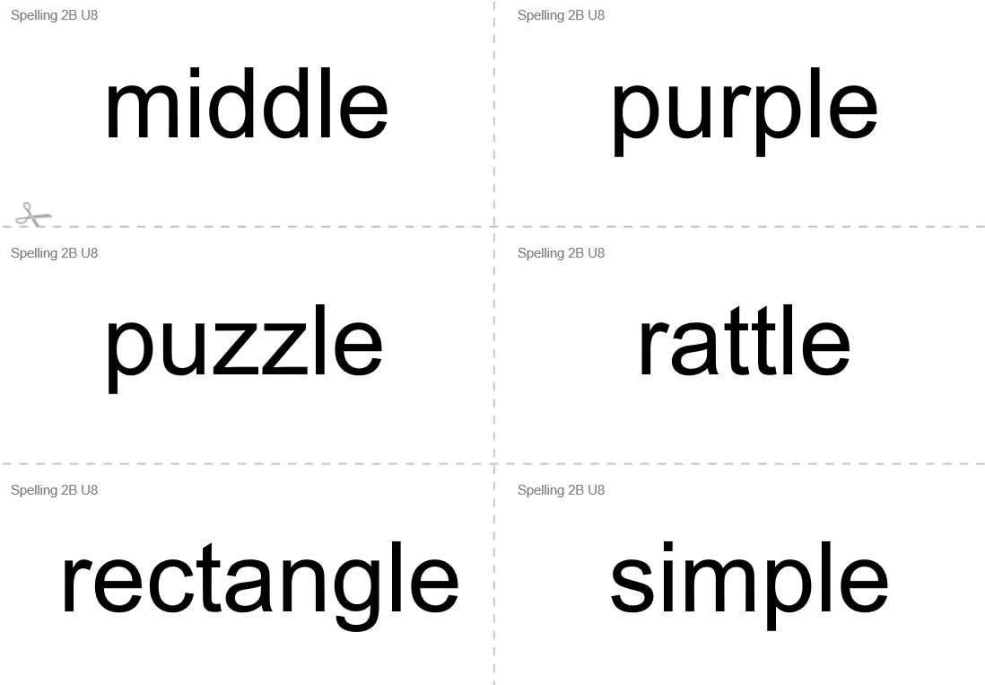  Try using each of these words in a sentence. Can you make silly sentences using two words?
  l
  l
  ll
  le
Art  Can you create a sculpture using in foil? Can you make it stand up in its own?  -Before you start, make a quick plan. How will you go about making the different features?  *Please send us a picture of your creation.  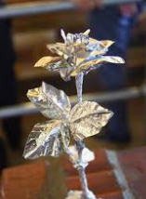  Here are a few ideas to get you started.  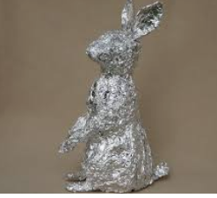  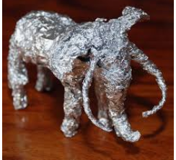 | Blue Peter Badges  Have a look at the website below and try to earn a Blue Peter Badge. They have released 6 new badges for the summer.  https://www.bbc.co.uk/cbbc/joinin/six-badges-of-summer?collection=6-badges-of-summer&xtor=CS8-1000-[Discovery_Cards]-[Multi_Site]-[SL07]-[PS_CBBC~N~~C_BluePeterBadgesOfSummer]  