Year 2 Home Learning
Week Commencing 29 June 2020- Monday
Please send your work to- year2@highworthcombined.co.uk
We always look forward to seeing your work. Please let us know if you need any help or have any questions.
English  Watch the following video and complete the activities below- Catch It.  https://www.literacyshed.com/catchit.html  Key words-  meerkat 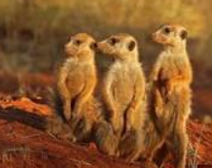  Vulture 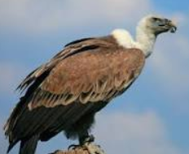  Dragon fruit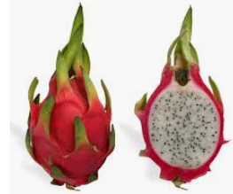  Monday-  What is happening in this story?  Who are the main characters?  How would you describe the characters? What do they look like and how do they act?  Tuesday  Write a recount of the story in past tense, describing the animals and the fruit. Write what happens from the beginning to the end. Try to use the character descriptions you used in the lesson on Monday to make your writing more interesting. | Maths  Warm up-  - 57+ 43= ___  - 72- 13 = ___  - 5 x ___ = 45  - Half of 18 is ___  Measure-  Recap- We looked at measuring length eariler in the school year.  What unit would we use to measure how long a football field is? meters  What unit would we use to measure how long a pencil is?  centimeters  How many centimeters make one meter?  Can you remember the rules for measuring objects?  Write directions for someone who wanted to measure an object. What do they need to do?  If you can’t remember everything about measuring have a look at the video below and complete the challenges.  https://www.bbc.co.uk/bitesize/articles/zcbwr2p  Give an example of somethings that you could easily measure in centimeters. Give a rough estimate of how long you think it is. Then if you have a tape measure or a ruler, measure the object. How close were you?  Repeat the activity with using meters.
Geography  We have looked the 7 continents. Can you remember all of them?  Asia, Africa, North America, South America, Antaritica, Europe and Australia.  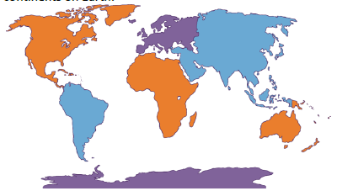  Australia is one of the world’s continents.  Watch the video below to learn more about Australia. Can you remember another name that some people use for the continent Australia? …Oceania!  https://www.bbc.co.uk/bitesize/articles/zhv8jhv  In the activity section at the end of lesson there is a video comparing two different cities. One is in England and the other is in Australia. Watch and then think about High Wycombe. How would you describe our town to other people? How is the environment similar or different to where we live? | Spelling  In some words, the ending that sounds like l is spelt al?  Today’s words have the ending that sounds like  l spelt al.  Try and read each of the words out loud.  capital animal  crystal magical  tropical festival  sandal  Can you hear a weak little uh sound in the last  syllable of these words? Capital, magical,  sandal.  To help you remember how to spell these  words, say each syllable in an exaggerated way  like this: ca/pi/tal, ma/gi/cal  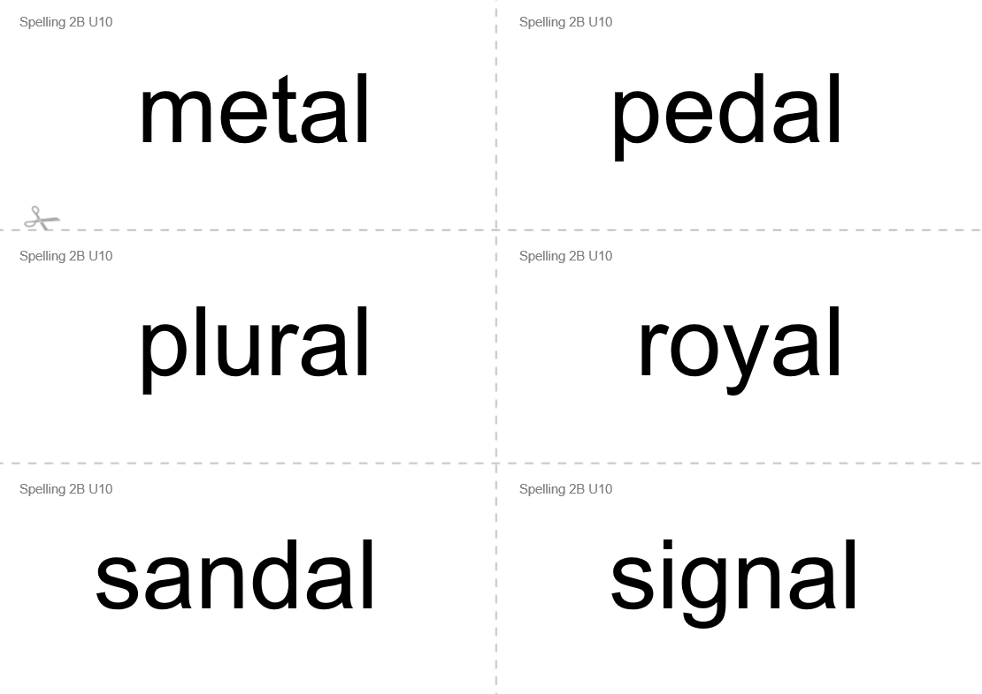  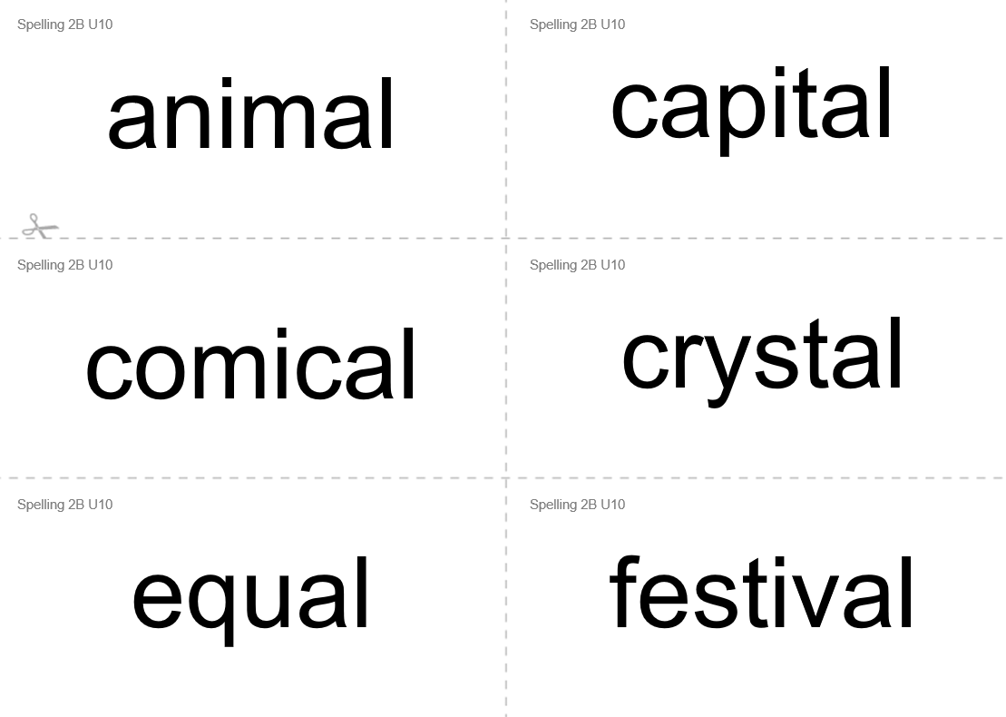  - Write 6 sentences using these words.  - Can you write a sentence using two or three words from the list?
Art  Catch It- Art  Draw a picture of your favourite part of the story from the English unit. Will you draw a picture of the meerkat, the vulture or both? Why did you decide to draw this particular part of the story?  Make sure you think about what the back ground of the picture looks like. Where do you think the setting is for the story? | Maths Challenge  Look at the attached Maths on the move challenge. How many of the challenges can you complete?  