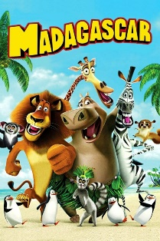

Year 4 Home Learning Wednesday 6th May 2020
Welcome to Year 4 film day!

WARNING! This is a lengthy looking matrix because it has lots of detail!
With their permission, we have been inspired to share this idea from the Thomas family! They have shared some days of fun and learning where the activities are inspired by a film.
The film we have chosen to plan activities around is Madagascar. We chose this because we know you have seen the film during wet breaks at school and, if you have Netflix, it is available to view. It would be great if you could connect with your family and enjoy watching the film again with someone in your household.
We have planned some activities using the African theme of Madagascar. Please feel free to invent your own activities too if you would like to. These could include finding Madagascar on a map or creating a fact file about Madagascar. Can you learn how to say hello to someone living in Madagascar? What sort of music or dance are native to Madagascar? The list of possible activities is long!
You could choose a different U rated film to inspire you to create activities. For example, The Hunchback of Notre Dame for a French theme or Mulan to learn about China (thank you Thomas family for these!).
We hope you will enjoy these ideas and look forward to hearing from you and seeing what you have been doing!
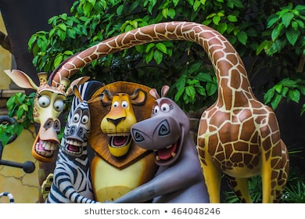
Remember this is something you could
continue for more than one day!
Mrs Sparkes and Mrs Stewart
Year 4 Home Learning – Wednesday 6th May 2020
Remarkable Writing!  Time for some Madagascar themed writing!  You can make your own choice about what you would like to write.  You could …  - Write a story – you could retell the story to create your own story using the characters and setting.  - Write a diary entry as one of the characters.  - Write a film review – what is it about? Who would enjoy it? Would you recommend it? Why?  - Write a fact file either about Madagascar or about one of the animals.  - Write an acrostic poem for MADAGASCAR or a poem of your own style inspired by the film.  Think about:  - What is the purpose of the writing you are about to complete? Eg an information text provides interesting facts.  - Similar texts we have used together at school to help you.  - Beginning by noting down your ideas including thinking about the structure you will use.  - Think about the vocabulary you will use - adjectives, adverbs, similes, alliteration, onomatopoeia, technical vocabulary (for information texts)  - How will you make this exciting for your reader?  You also need to remember all the grammar parts of a tool kit:  Capital letters and punctuation.  Spelling.  Does is make sense when you read it?  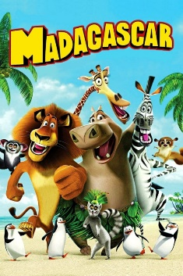  Paragraphs.  Spelling.  EDITING!  Research tip:  Try Espresso  (logon details are on the  Website). | Sensible SPaG!  First of all, a flashback to our last unit of writing at school! Holly has created a Shakespeare themed wordsearch (attached below) for you to enjoy!  You are going to use MADAGASCAR to practice thinking about word classes.  Can you think of an adverb for each letter of the word MADAGASCAR? How adventurous will your words be?  Now add verbs to go with your adverbs, then at the same time you will have created some alliteration. These could be combinations of verbs / adverbs that go together or can you find some funny combinations?  Put this together and you can write a list poem (that is also an acrostic poem!).  Challenge: choose an animal name and do the same thing!  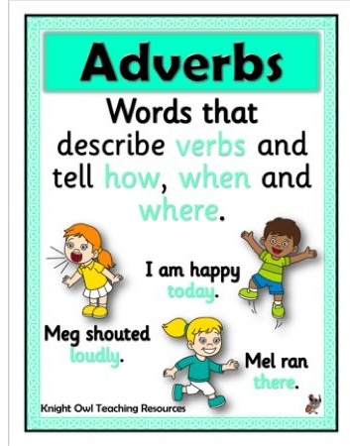  Extra challenge: Can you write some comprehension questions about the film? You will need to provide a separate answer sheet and we may be able to share them for others to try!

Super Science!  The African Savannah  Using your knowledge from the film, Madagascar, or by researching, can you create an African savannah diorama?  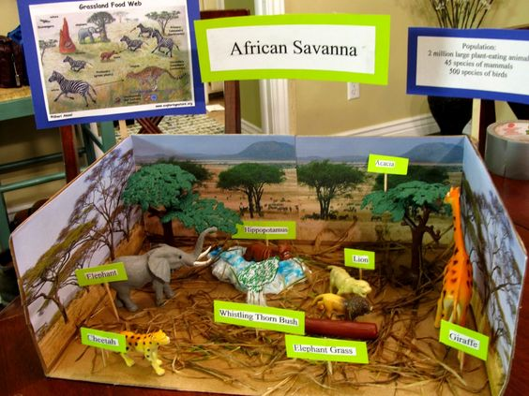  Think about the habitat; the landscape, what plants grow there, the types of animals and where they would most likely be found, what else might you see?  Using an old shoe box, or any old box, you begin by creating the background. You could use paper from old magazines to create a collage, or paint, glue sand and dry grass. (be creative and use what you can find at home.) Then you add the animals, which you can draw. Remember to add some informative labels.  or  Consolidating the work you did on food chains, you could access this BBC bitesize activity where you create food chains from the savannah. Use the link below.  https://toybox.tools.bbc.co.uk/activities/id/gm2zlfh9hq/exitGameUrl/https%3A%2F%2Fwww.bbc.co.uk%2Fbitesize%2Ftopics%2Fzxfrwmn%2Farticles%2Fzh9c47h/palette/colour-palette-7/language/en-GB/project/blocks-bitesize | Terrific Topic!  African animal art  Look at the following images of animal skins. (I wonder why they are all different?)  Can you identify which African animal they belong to?  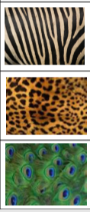  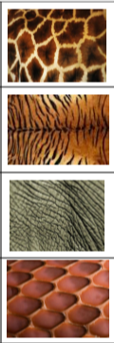  Now using these you are going to create a pattered border for a page of artwork.  - On a plain piece of paper, draw a 3cm border all the way around.  - Create a pattern using an idea from an animal skin.  e.g. 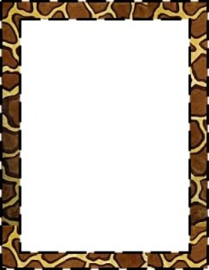  - Choose an African animal and draw a large outline of the animal on your page.  - Fill the animal with interesting designs to create your own piece of mindfulness art.  - You could colour it in as part of your wellbeing activity, or  - We would love you to email us a copy of your picture to have a go ourselves. We could even include it in our home learning matrix for others to colour in.  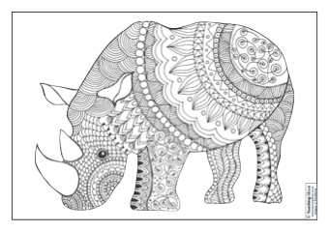  Here is an example:
Marvellous Maths!  Times Tables and division practice for quick recall. You can use this link: https://www.topmarks.co.uk/maths-games/daily10  Without internet: You could write them out, chant them walking around or up and down the stairs (exercise too!), ask someone to quiz you or create your own beat the clock grid. Can you create a rap / song / poem to help you practice any times tables you find more tricky?  Animal riddle  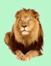  + + =30  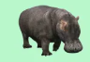  + + = 20  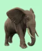  + + = 9  X = ?  Now try this one.  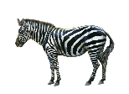  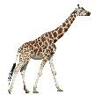  + = 6  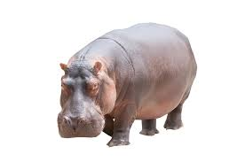  + = 10  + = 8  + + = ?  Can you solve the riddle?  (HINT: what is the value of each animal?)  Challenge: Can you make a maths riddle of your own? You could use a different calculation? | Wonderful Wellbeing!  This week’s winning way to wellbeing is:  Keep Learning  Below, you will find the instructions to make an origami jumping frog. Have fun.  Perhaps you could create a little track around the house and see if your frog can follow it.  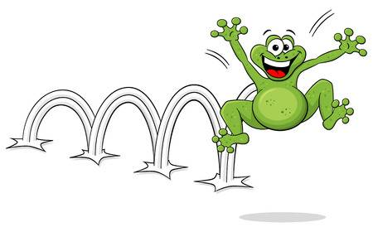  Remember to keep adding to your Ramadan kindness calendar!
We hope you enjoy completing these activities. If you wish to present the information in a different way, or to extend the activity, we would be delighted to see what you produce. For all Twinkl resources and access to Espresso, please refer to the log on details under the Home Learning Ideas on the school website. If you have access to the internet or iPlayer, remember that you can find lots of useful activities and mini lessons on BBC Bitesize. Oak National Academy is another great website.

A Jumping Frog
A frog that jumps need not be live. Find out how to make a paper frog that jumps right here!
You will need:
- A4 size paper
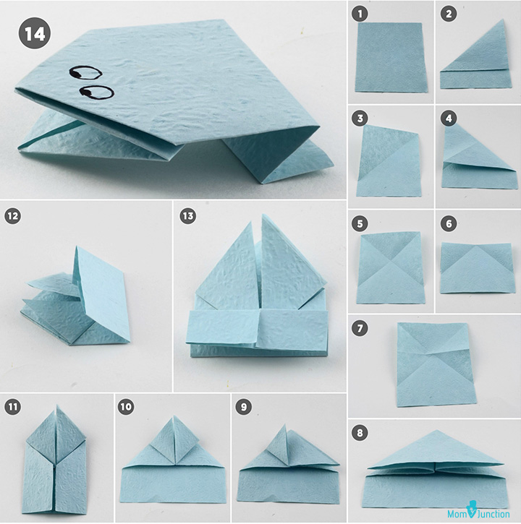
- Colour pen
How to:
- Fold the top left corner of the rectangular sheet of paper, taking it to the right. See image 2.
- Unfold. Now fold the top right corner the same way. Unfold.
- Fold the paper backward, at the point where the creases of the “X” meet. You should see something like in image 6. Unfold the top.
- Now form a triangle by bringing the creases together. It may seem tricky, but all you need to do is hold the paper at the folded ends on either side and push inwards slowly. See image 8.
- Fold the left corner of the triangle towards the top of the triangle, as shown in image 9.
- Repeat with the other side as seen in image 10. You will see two triangles on either side.
- Now fold the two triangles in half (inwards) to get what you see in image 11.
- Fold the bottom to touch the right edges of the diamond or kite-like shape on top. See image 12.
- Fold the bottom rectangle in half, as seen in image 13.
- Turn it over to add eyes. To make the frog jump, press its back!

Holly’s Shakespeare Wordsearch

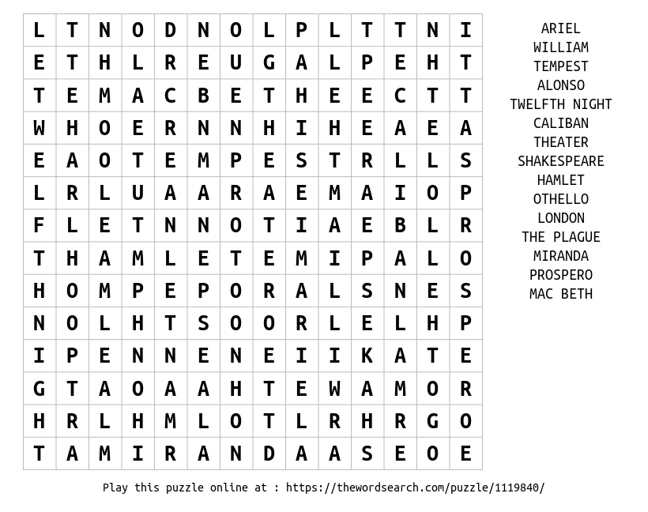
(can you spot one spelling mistake?!)

