

Year 4 Home Learning – Monday 18th May 2020
Please send us your work to:
Year4@highworthcombined.co.uk

EXCITING NEWS! HAVE YOU GOT THE POWER IN YOU? Young Voices are inviting you to be part of the largest children’s choir at home. The song is going to be The Power in Me so you will all know it from singing it at school (and 4NS we used it in our class assembly!). Go to the Young Voices website and find the Power in Me Singing Challenge tab to read all about how you can join in.
SAVE THE DATE: 2 June 2020 at 2.30pm. We will be there and hope you will too!

You will notice that today’s matrix looks a little bit different. For this week, we are setting you a special Time Capsule Project throughout the week, as well as including some other activities to keep you busy! Please keep all your time capsule work together at home (as well as sending it to us!)
You will find a document called ‘Time Capsule Project’ in the Home Learning section of the school website that includes some of the activities for all of this week and includes an overview of what we hope to achieve. We will guide you through the activities on each matrix. For this week, you are going to keep a diary of your experiences in lockdown to record your experiences and thoughts with a theme for each day.
TIME CAPSULE ACTIVITIES
Monday 18.5.20  Day 1: What I do  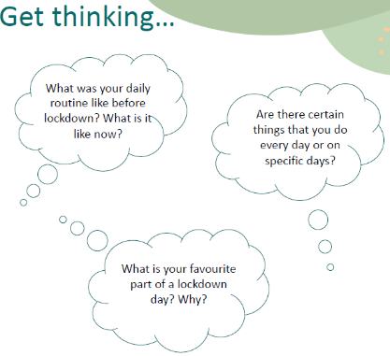  You are going to tell us about a day of your life in lockdown.  Thinking about these questions, you could make a cartoon strip of your day (including some writing), you could write a recount or a diary entry. Remember you will be writing in the first person!  Are there things you do that are the same every day or is each day different?  Challenge: You could include a comparison and think about the differences between a day in lockdown and a day before lockdown. Which do you prefer? Why? | Tuesday 19.5.20  Day 2: My environment  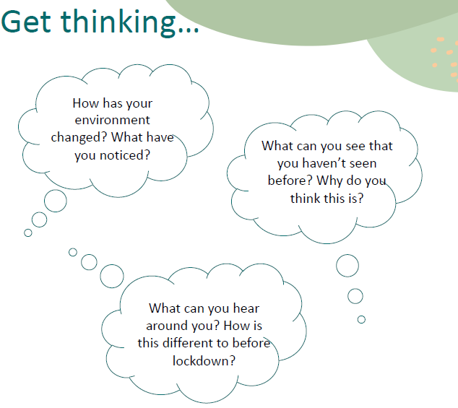  Look out of your window… is there anything different about what you can see or hear? Can you create a piece of art to capture your environment at this time?  Think about what you include so when you look back it helps you remember this time clearly.  Challenge: Can you explain what is different about the world around you at the moment?
OTHER ACTIVITIES
A riddle is a question that creates endless possibilities to develop problem solving skills. They leave us clueless and make us hungry for more!
Here is an example: What gets wetter the more it dries? (A towel!)

Riddles come in lots of different forms. You will find some more brain teasers like this example as well as some maths related riddles below this matrix. Have a go and have some fun!
I am small as an ant and big as a whale,
I can soar through the air like a bird with a tail.
I can be seen by day and not by night,
I can be seen with a big flash of light.
I follow whoever controls me by the sun,
but I fade away when dark fell like a ton.
What am I?

Riddles can also be written as short poems, like these:

I have streets but no pavement,
I have cities but no buildings,
I have forests but no trees,
I have rivers yet no water.
What am I?

You will find some riddles to try as a word document with the Year 4 matrices on the website.

Challenge: Can you write some of your own riddles (with a separate answer sheet!) that we can try and we may then share them on a future matrix for the rest of Year 4 to try! Try a poem style riddle for an extra challenge!
MAGNIFICENT MATHS Chilli pepper challenge time!
  - 87 + 65  - 145 + 281  - 543 + 341  - 392 + 88  - 69 – 54  - 76 – 42  - 265 – 143  - 473 - 255  - On a road trip, a family travelled 167 km on the first day and 197 km on the second day. How far had they travelled from home?  - Miso spent £57 of his birthday money on some new sports equipment. He got £85 for his birthday. How much of his birthday money has he got left? | - 489 +372  - 698 + 573  - 2474 + 4678  - 6743 + 764  - 589-396  - 948 – 693  - 4563 – 1947  - 5000 – 1856  Now for some word problems!  Click on the link below. You can choose which set of questions to try, the one star, two star or 3 star problems. You will need to logon to Twinkl to get access to the pages for free. On the next page is the reminder of how you can logon to Twinkl. https://www.twinkl.co.uk/resource/t2-m-2462-differentiated-addition-and-subtraction-word-problem-activity-sheets | 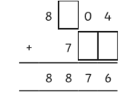  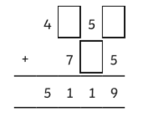  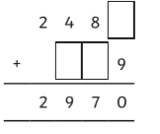  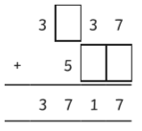

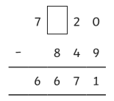

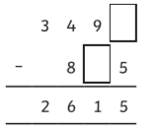

Now for some word problems! Click on the link below. You will need to logon to Twinkl to get access the pages for free. On the next page is the reminder of how you can logon to Twinkl. https://www.twinkl.co.uk/resource/t2-m-2462-differentiated-addition-and-subtraction-word-problem-activity-sheets

Below is a reminder on how to access Twinkl . 